Assignment

1. Class polygon contains data member width and height and public method set_value() to assign values to width and height. Class Rectangle and Triangle are inherited from polygon class. Both the classes contain public method calculate_area() to calculate the area of Rectangle and Triangle. Use base class pointer to access the derived class object and show the area calculated.

**Code:**

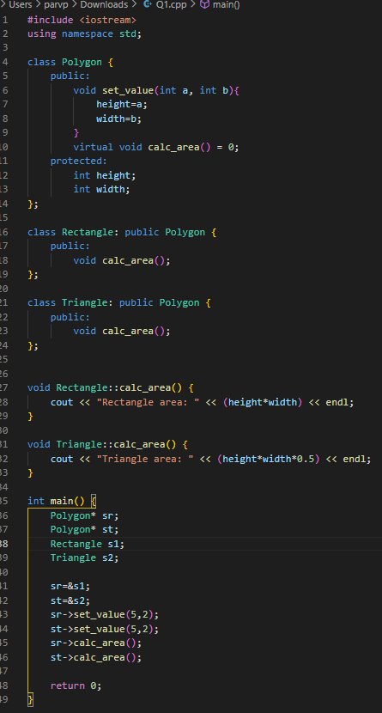

**Output:**



1. Write a program to create a class shape with functions to find area of and display the name of the shape and other essential component of the class. Create derived classes circle, rectangle and trapezoid each having overridden functions area and display. Write a suitable program to illustrate virtual functions.

**Code:**

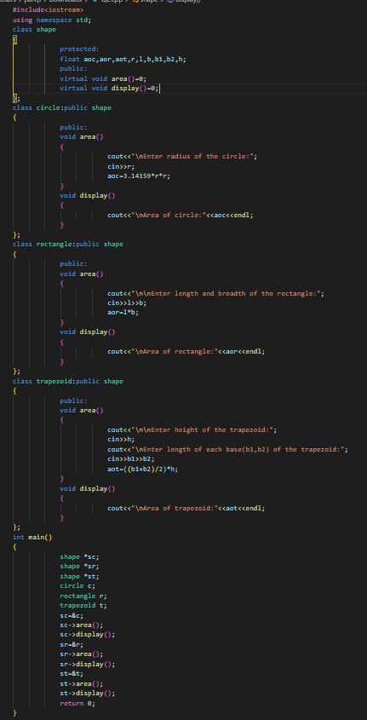

**Output:**

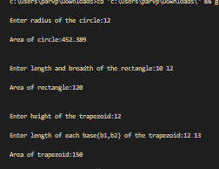

3. Write a program with Student as abstract class and create derive classes Engineering, Medicine and Science from base class Student. Create the objects of the derived classes and process them and access them using array of pointer of type base class Student.

**Code:**

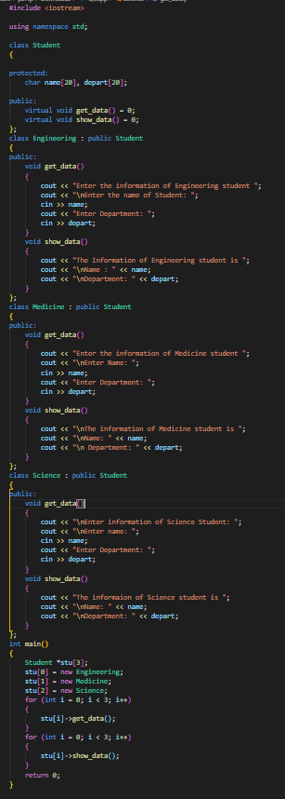

**Output:**

